1. ***Presenting Phase:***
2. ***Present Atam***

***2- Present Business Drivers***

***(i)-Functionalities***

1. The software can register patient
2. The Software must allow to look into favourite time and book appointment
3. The software allow patient to upload form and wright the information or medical history
4. The software must allow Patient to look for doctors
5. The Patient can check the medicine recommended by doctor
6. The Patient will be able to check test
7. The Patient must have facility of online payment through any well-known services
8. The Doctor can check any Patients record
9. The doctor can suggest test and medicine for Patient
10. The Doctor is free to make any change regarding appointment
11. The lab assistant can check suggested test of specific patient
12. The lab assistant can upload test results
13. The chemist can check medicines
14. The chemist account link with online payment system

***(ii)Stakeholders***

Hospital Management

Government Health Department

Doctor

Nurse

Patient

Chemist

Laboratory

Attached Bank

***3-Present Architectural Style***

***(i)-Suggested Architectural style***

form above discussed functionalities it is cleared that we will use the style of architecture which have an only one centre or database (like The information container) and every actor component take, update, insert, and add value to the system for this the best style is **Repository style**

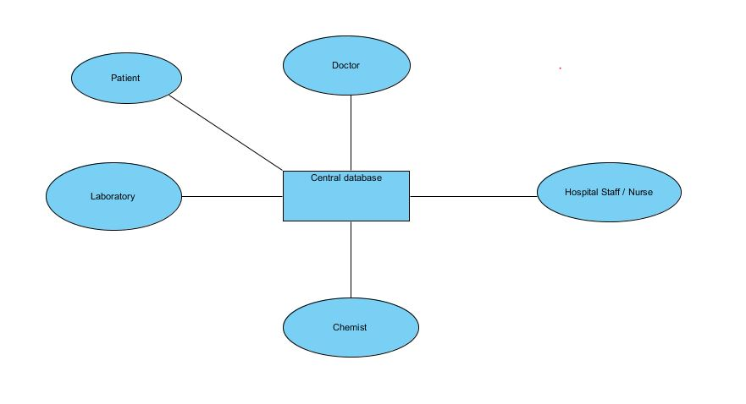

***(B). Investigation and Analysis Phase:***

***4. Identify architectural approaches***

This Architectural style is used as it is having only database which is being used by everyone so it may compromise the data integrity for this purpose this system have to go with such approach so that every user has to just approach to certain data this will increase the performance and security as the limited data is accessible for person.

The Other style which can be used are

**Blacked board architectural style**

**Pipe and Filter Architectural style**

***5. Generate quality attribute utility tree***

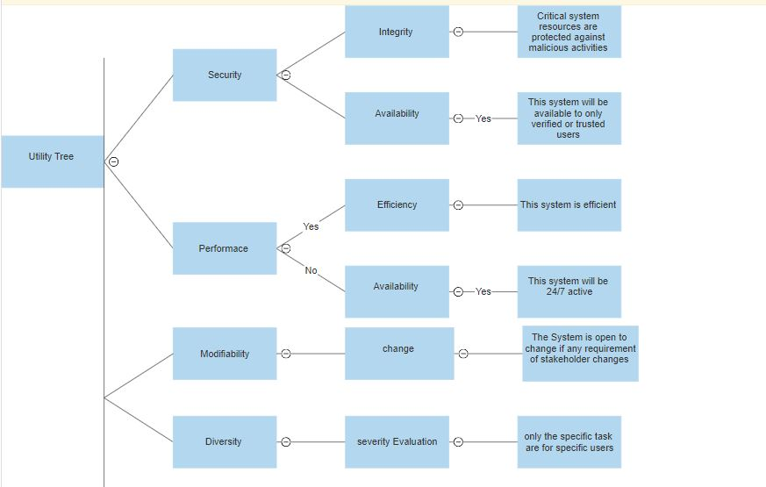

|  |  |  |
| --- | --- | --- |
| ***Quality Attributes*** | ***Stimulus*** | ***Response*** |
| Security | If someone is trying to access the restricted functionality or a user is trying to look at other users data | The user will receive a warning massage and if user trying to do so system will block this user’s account |
| Performance | If the system is being used at time of peak hours this may affect the performance | This system is design to help more user at a time but if it’s limit exceeded it will be solved using the time sharing |
| Modifiability | This system is open to change what if there are too many new requirements for system will it take care of that | There is limit to make change if this limit approaches then it is batter to make new system. |
| Diversity | The user wants to do a function that is not for him like patient wants to suggest a test . | This function is restricted so user will receive warning massages until he leaves that function. |

***Architecture trade off points***

This system is being build up for the hospital

There will be many users which will use this system at a time

The system must have ability to perform well

The security of the data being provided by user must be confidential

The system must have ability to take care of performance at peak time.